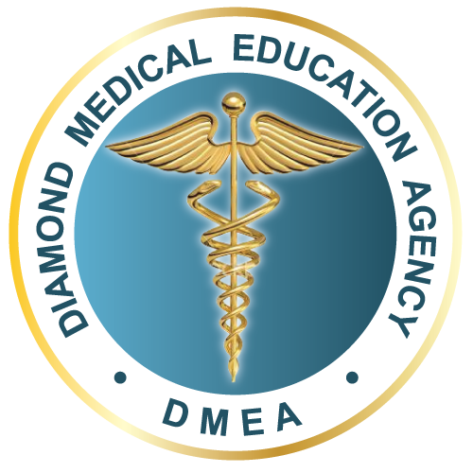
Application Form

University of Debrecen Medical School

Program of study for which you would like to apply: _________________________________________________

In case of Basic Medicine Course, you would like to continue on: _________________________________________________

Academic Year/ Semester: _________________________________________________

PERSONAL INFORMATION

Family Name: _________________________________________________

Given Name (s): _________________________________________________

Sex: _________ Male

_______ Female

Date of Birth (day/month/year): _________________________________________________

Place of birth (city/country): _________________________________________________

Mother's Maiden name (full name before marriage): _________________________________________________

First language: _________________________________________________

Nationality: _________________________________________________

Proficiency in English: _________________________________________________

PASSPORT

Passport number: ________________________________________________

Valid till (day/month/year): ________________________________________________

Issued by (Country): ________________________________________________

Diamond Medical Education Agency | T: 1 (647) 996-505 | E: info@dmea.ca | www.dmea.ca

CONTACT DETAILS (in your country)

Address: _________________________________________________

City: _________________________________________________

Country: _________________________________________________

Post/Zip code: _________________________________________________

Telephone: ____________________________________________________

E-mail: ________________________________________________

Skype ID: ______________________________________

EDUCATION HISTORY

High School: _________________________________________________

From (year): ___________________ To: __________________________

Grade completed: ________________________________________________

University or College: ________________________________________________

From (year): ___________________ To: __________________________

Degrees / Diplomas: _________________________________________________

APPLICATION TYPE:

Please choose only one option:

1. I would like to transfer to the University of Debrecen, and I hereby submit all available school documents with my application for the purpose of evaluation of my previous studies.

2. I would like to apply for subject exemptions on the basis of my previous studies, and I hereby submit all available school documents with my application. I understand that my documents will be evaluated upon successfully passing the entrance examination to the first year of the desired program.

3. I am applying as a freshman, and I do not want to apply for any exemptions. I am aware that I will not be able to submit any more exemption requests to the Educational Sub-Committee throughout my entire studies at the University of Debrecen.

Diamond Medical Education Agency | T: 1 (647) 996-505 | E: info@dmea.ca | www.dmea.ca

Declaration

With my signature below:

1. I accept that I will not be able to submit any more subject exemption requests throughout my entire studies at the UD.
2. I accept that the University of Debrecen might turn to my educational institution for verification of my school documents.
3. I certify that the data in this form are true, complete and correct to the best of my knowledge and belief. I understand that any misrepresentation or material omission made on the Application Form will result in the application being void and in termination of my application.

4. I confirm that this application fully accords with my intentions, and hereby I submit this application to the University of Debrecen with the indicated details.

5. By signing this declaration, I acknowledge that the agent acting on behalf of the University of Debrecen is the one responsible for compliance with the data management and data protection rules in my country of origin, and on my request the agent shall provide me with detailed information regarding data management process.

I confirm that this declaration fully accords with my intensions, and hereby sign the application form.

_________________________________________________
Date Signature

Diamond Medical Education Agency | T: 1 (647) 996-505 | E: info@dmea.ca | www.dmea.ca

Application Checklist

University of Debrecen Medical School

1. Completed application form (as per passport)

2. Academic transcripts and certificates from previous studies (high school, college, university, other awards and course descriptions if available). Documents can be sent in scanned version but later on we will need the original ones, which should be presented at the oral entrance examination or at registration at the University, at the latest

3. Proof of English Language proficiency in case of applicants from countries where the official/native language is not English

4. Short curriculum vitae (Resume)

5. Short letter of motivation: "Why I Want To Become a Physician?"

6. Copies of relevant pages of the passport

7. One recent photograph.

8. Signed declaration letter providing the applicant's consent to Diamond for Medical Education for forwarding his/her application material to the University of Debrecen.

Diamond Medical Education Agency | T: 1 (647) 996-505 | E: info@dmea.ca | www.dmea.ca

